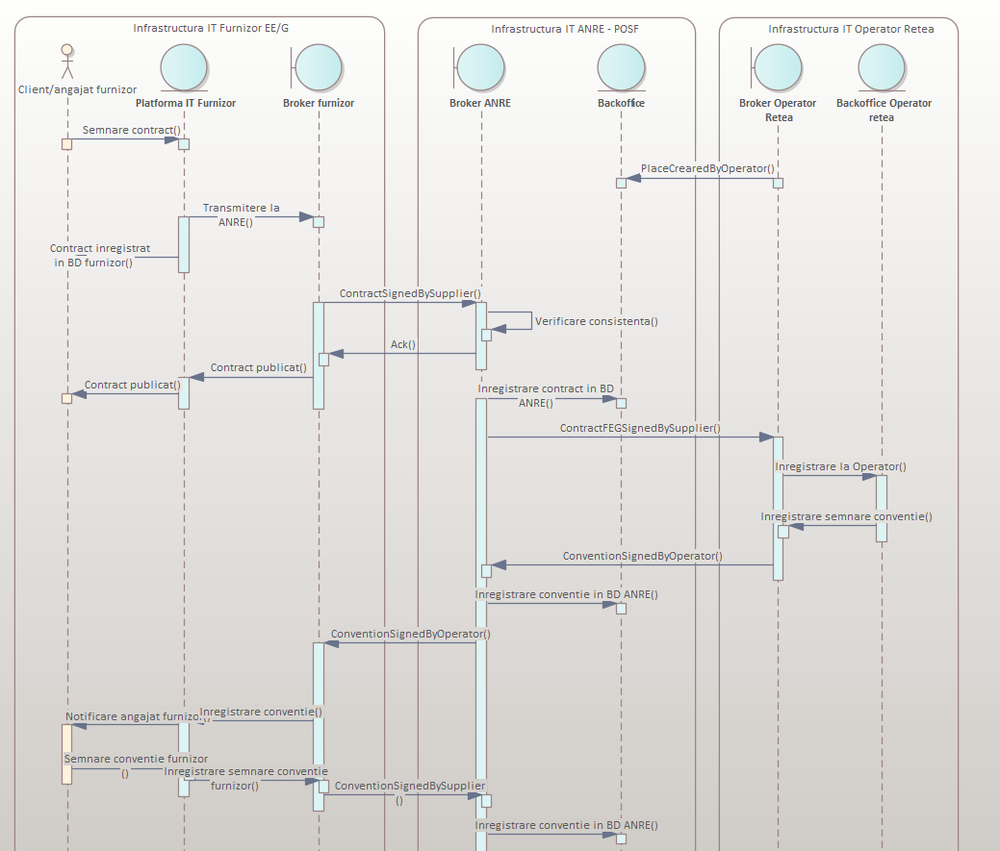

Schema ANRESchema.xsd

schema location:
attributeFormDefault:
elementFormDefault:
targetNamespace: | http://www.anre.ro/ANRESchema

Complex types | Simple types
Address | ConnectionType
City | ConsumptionCategory
Client | ContractType
Contract | CounterType
ContractSignedByClient | County
LegalID | Email
Message | Guid
Operator | Incorporation
Place | LegalIDType
PlaceCreatedByOperator | NetworkType
PlaceUpdatedByOperator | Phone
Position | PlaceType
Supplier | TechnicalDataStatus
TechnicalData
TechnicalDataElectricity
TechnicalDataGas

complexType Address
diagram | 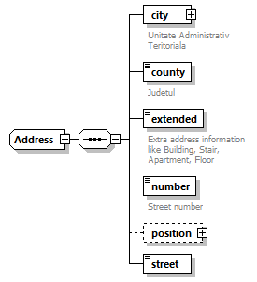
namespace | http://www.anre.ro/ANRESchema
used by
  elements | Address Client/address Operator/address Place/address Supplier/address Contract/executionAddress
source | <xs:complexType name="Address">  <xs:sequence>  <xs:element name="city" type="anre:City" minOccurs="1" maxOccurs="1">  <xs:annotation>  <xs:documentation>Unitate Administrativ Teritoriala</xs:documentation>  </xs:annotation>  </xs:element>  <xs:element name="county" type="anre:County" minOccurs="1" maxOccurs="1">  <xs:annotation>  <xs:documentation>Judetul</xs:documentation>  </xs:annotation>  </xs:element>  <xs:element name="extended" type="xs:string" minOccurs="1" maxOccurs="1">  <xs:annotation>  <xs:documentation>Extra address information like Building, Stair, Apartment, Floor</xs:documentation>  </xs:annotation>  </xs:element>  <xs:element name="number" type="xs:string" minOccurs="1" maxOccurs="1">  <xs:annotation>  <xs:documentation>Street number</xs:documentation>  </xs:annotation>  </xs:element>  <xs:element name="position" type="anre:Position" minOccurs="0" maxOccurs="1"/>  <xs:element name="street" type="xs:string" minOccurs="1" maxOccurs="1"/>  </xs:sequence>  </xs:complexType>

element Address/city
diagram | 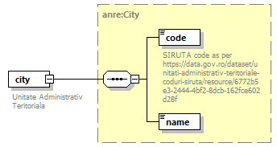
type | anre:City
properties
  content | complex
annotation
  documentation
  Unitate Administrativ Teritoriala
source | <xs:element name="city" type="anre:City" minOccurs="1" maxOccurs="1">  <xs:annotation>  <xs:documentation>Unitate Administrativ Teritoriala</xs:documentation>  </xs:annotation>  </xs:element>

element Address/county
diagram | 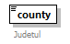
type | anre:County
properties
  content | simple
facets
  Kind | Value | Annotation
  enumeration | AB
  enumeration | AG
  enumeration | AR
  enumeration | B
  enumeration | BC
  enumeration | BH
  enumeration | BN
  enumeration | BR
  enumeration | BT
  enumeration | BV
  enumeration | BZ
  enumeration | CJ
  enumeration | CL
  enumeration | CS
  enumeration | CT
  enumeration | CV
  enumeration | DB
  enumeration | DJ
  enumeration | GJ
  enumeration | GL
  enumeration | GR
  enumeration | HD
  enumeration | HR
  enumeration | IF
  enumeration | IL
  enumeration | IS
  enumeration | MH
  enumeration | MM
  enumeration | MS
  enumeration | NT
  enumeration | OT
  enumeration | PH
  enumeration | SB
  enumeration | SJ
  enumeration | SM
  enumeration | SV
  enumeration | TL
  enumeration | TM
  enumeration | TR
  enumeration | VL
  enumeration | VN
  enumeration | VS
annotation
  documentation
  Judetul
source | <xs:element name="county" type="anre:County" minOccurs="1" maxOccurs="1">  <xs:annotation>  <xs:documentation>Judetul</xs:documentation>  </xs:annotation>  </xs:element>

element Address/extended
diagram | 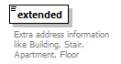
type | xs:string
properties
  content | simple
annotation
  documentation
  Extra address information like Building, Stair, Apartment, Floor
source | <xs:element name="extended" type="xs:string" minOccurs="1" maxOccurs="1">  <xs:annotation>  <xs:documentation>Extra address information like Building, Stair, Apartment, Floor</xs:documentation>  </xs:annotation>  </xs:element>

element Address/number
diagram | 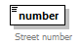
type | xs:string
properties
  content | simple
annotation
  documentation
  Street number
source | <xs:element name="number" type="xs:string" minOccurs="1" maxOccurs="1">  <xs:annotation>  <xs:documentation>Street number</xs:documentation>  </xs:annotation>  </xs:element>

element Address/position
diagram | 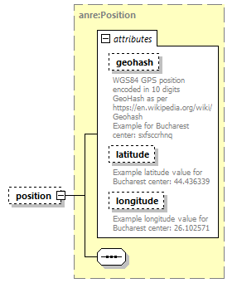
type | anre:Position
properties
  minOcc | 0
  maxOcc | 1
  content | complex
attributes
  Name | Type | Use | Default | Fixed | Annotation
  geohash | xs:string | optional
    documentation
    WGS84 GPS position encoded in 10 digits GeoHash as per https://en.wikipedia.org/wiki/Geohash
    Example for Bucharest center: sxfsccrhnq
  latitude | xs:string | optional
    documentation
    Example latitude value for Bucharest center: 44.436339
  longitude | xs:string | optional
    documentation
    Example longitude value for Bucharest center: 26.102571
source | <xs:element name="position" type="anre:Position" minOccurs="0" maxOccurs="1"/>

element Address/street
diagram | 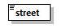
type | xs:string
properties
  content | simple
source | <xs:element name="street" type="xs:string" minOccurs="1" maxOccurs="1"/>

complexType City
diagram | 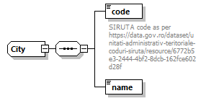
namespace | http://www.anre.ro/ANRESchema
used by
  elements | City Address/city
source | <xs:complexType name="City">  <xs:sequence>  <xs:element name="code" type="xs:string" minOccurs="1" maxOccurs="1">  <xs:annotation>  <xs:documentation>SIRUTA code as per https://data.gov.ro/dataset/unitati-administrativ-teritoriale-coduri-siruta/resource/6772b5e3-2444-4bf2-8dcb-162fce602d28f</xs:documentation>  </xs:annotation>  </xs:element>  <xs:element name="name" type="xs:string" minOccurs="1" maxOccurs="1"/>  </xs:sequence>  </xs:complexType>

element City/code
diagram | 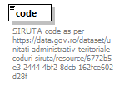
type | xs:string
properties
  content | simple
annotation
  documentation
  SIRUTA code as per https://data.gov.ro/dataset/unitati-administrativ-teritoriale-coduri-siruta/resource/6772b5e3-2444-4bf2-8dcb-162fce602d28f
source | <xs:element name="code" type="xs:string" minOccurs="1" maxOccurs="1">  <xs:annotation>  <xs:documentation>SIRUTA code as per https://data.gov.ro/dataset/unitati-administrativ-teritoriale-coduri-siruta/resource/6772b5e3-2444-4bf2-8dcb-162fce602d28f</xs:documentation>  </xs:annotation>  </xs:element>

element City/name
diagram | 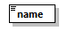
type | xs:string
properties
  content | simple
source | <xs:element name="name" type="xs:string" minOccurs="1" maxOccurs="1"/>

complexType Client
diagram | 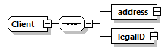
namespace | http://www.anre.ro/ANRESchema
used by
  elements | Client Contract/client
source | <xs:complexType name="Client">  <xs:sequence>  <xs:element name="address" type="anre:Address" minOccurs="1" maxOccurs="1"/>  <xs:element name="legalID" type="anre:LegalID" minOccurs="1" maxOccurs="1"/>  </xs:sequence>  </xs:complexType>

element Client/address
diagram | 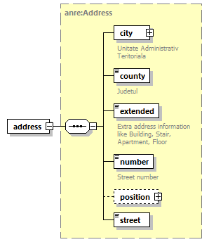
type | anre:Address
properties
  content | complex
source | <xs:element name="address" type="anre:Address" minOccurs="1" maxOccurs="1"/>

element Client/legalID
diagram | 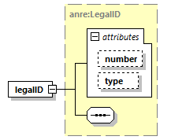
type | anre:LegalID
properties
  content | complex
attributes
  Name | Type | Use | Default | Fixed | Annotation
  number | xs:string | optional
  type | anre:LegalIDType | optional
source | <xs:element name="legalID" type="anre:LegalID" minOccurs="1" maxOccurs="1"/>

complexType Contract
diagram | 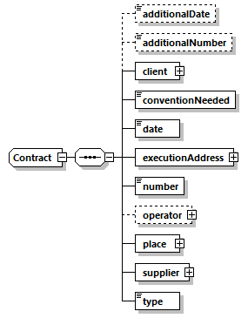
namespace | http://www.anre.ro/ANRESchema
used by
  elements | Contract ContractSignedByClient/contract
source | <xs:complexType name="Contract">  <xs:sequence>  <xs:element name="additionalDate" type="xs:date" minOccurs="0" maxOccurs="1"/>  <xs:element name="additionalNumber" type="xs:string" minOccurs="0" maxOccurs="1"/>  <xs:element name="client" type="anre:Client" minOccurs="1" maxOccurs="1"/>  <xs:element name="conventionNeeded" type="xs:boolean" minOccurs="1" maxOccurs="1"/>  <xs:element name="date" type="xs:date" minOccurs="1" maxOccurs="1"/>  <xs:element name="executionAddress" type="anre:Address" minOccurs="1" maxOccurs="1"/>  <xs:element name="number" type="xs:string" minOccurs="1" maxOccurs="1"/>  <xs:element name="operator" type="anre:Operator" minOccurs="0" maxOccurs="1"/>  <xs:element name="place" type="anre:Place" minOccurs="1" maxOccurs="1"/>  <xs:element name="supplier" type="anre:Supplier" minOccurs="1" maxOccurs="1"/>  <xs:element name="type" type="anre:ContractType" minOccurs="1" maxOccurs="1"/>  </xs:sequence>  </xs:complexType>

element Contract/additionalDate
diagram | 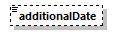
type | xs:date
properties
  minOcc | 0
  maxOcc | 1
  content | simple
source | <xs:element name="additionalDate" type="xs:date" minOccurs="0" maxOccurs="1"/>

element Contract/additionalNumber
diagram | 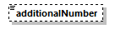
type | xs:string
properties
  minOcc | 0
  maxOcc | 1
  content | simple
source | <xs:element name="additionalNumber" type="xs:string" minOccurs="0" maxOccurs="1"/>

element Contract/client
diagram | 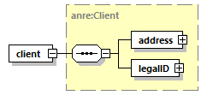
type | anre:Client
properties
  content | complex
source | <xs:element name="client" type="anre:Client" minOccurs="1" maxOccurs="1"/>

element Contract/conventionNeeded
diagram | 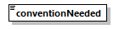
type | xs:boolean
properties
  content | simple
source | <xs:element name="conventionNeeded" type="xs:boolean" minOccurs="1" maxOccurs="1"/>

element Contract/date
diagram | 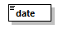
type | xs:date
properties
  content | simple
source | <xs:element name="date" type="xs:date" minOccurs="1" maxOccurs="1"/>

element Contract/executionAddress
diagram | 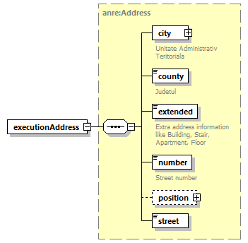
type | anre:Address
properties
  content | complex
source | <xs:element name="executionAddress" type="anre:Address" minOccurs="1" maxOccurs="1"/>

element Contract/number
diagram | 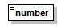
type | xs:string
properties
  content | simple
source | <xs:element name="number" type="xs:string" minOccurs="1" maxOccurs="1"/>

element Contract/operator
diagram | 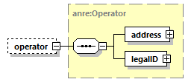
type | anre:Operator
properties
  minOcc | 0
  maxOcc | 1
  content | complex
source | <xs:element name="operator" type="anre:Operator" minOccurs="0" maxOccurs="1"/>

element Contract/place
diagram | 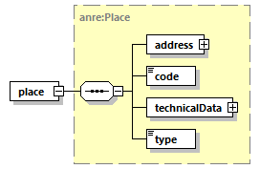
type | anre:Place
properties
  content | complex
source | <xs:element name="place" type="anre:Place" minOccurs="1" maxOccurs="1"/>

element Contract/supplier
diagram | 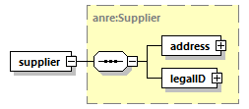
type | anre:Supplier
properties
  content | complex
source | <xs:element name="supplier" type="anre:Supplier" minOccurs="1" maxOccurs="1"/>

element Contract/type
diagram | 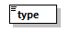
type | anre:ContractType
properties
  content | simple
facets
  Kind | Value | Annotation
  enumeration | FURNIZARE
  enumeration | RETEA
  enumeration | TRANSPORT
source | <xs:element name="type" type="anre:ContractType" minOccurs="1" maxOccurs="1"/>

complexType ContractSignedByClient
diagram | 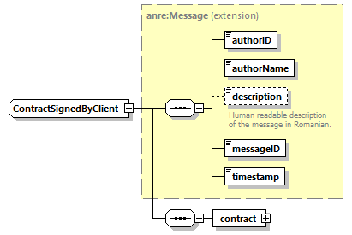
namespace | http://www.anre.ro/ANRESchema
type | extension of anre:Message
properties
  base | anre:Message
used by
  element | ContractSignedByClient
source | <xs:complexType name="ContractSignedByClient">  <xs:complexContent>  <xs:extension base="anre:Message">  <xs:sequence>  <xs:element name="contract" type="anre:Contract" minOccurs="1" maxOccurs="1"/>  </xs:sequence>  </xs:extension>  </xs:complexContent>  </xs:complexType>

element ContractSignedByClient/contract
diagram | 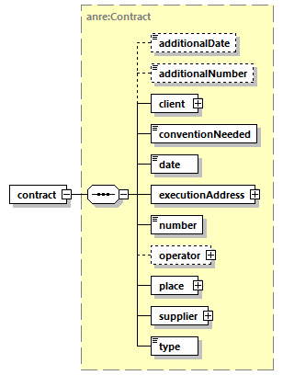
type | anre:Contract
properties
  content | complex
source | <xs:element name="contract" type="anre:Contract" minOccurs="1" maxOccurs="1"/>

complexType LegalID
diagram | 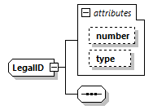
namespace | http://www.anre.ro/ANRESchema
used by
  elements | LegalID Client/legalID Operator/legalID Supplier/legalID
attributes
  Name | Type | Use | Default | Fixed | Annotation
  number | xs:string | optional
  type | anre:LegalIDType | optional
source | <xs:complexType name="LegalID">  <xs:sequence/>  <xs:attribute name="number" type="xs:string" use="optional"/>  <xs:attribute name="type" type="anre:LegalIDType" use="optional"/>  </xs:complexType>

attribute LegalID/@number
type | xs:string
properties
  use | optional
source | <xs:attribute name="number" type="xs:string" use="optional"/>

attribute LegalID/@type
type | anre:LegalIDType
properties
  use | optional
facets
  Kind | Value | Annotation
  enumeration | CNP
  enumeration | CUI
  enumeration | OTHER
  enumeration | PASSPORT
source | <xs:attribute name="type" type="anre:LegalIDType" use="optional"/>

complexType Message
diagram | 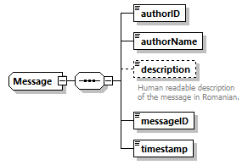
namespace | http://www.anre.ro/ANRESchema
used by
  element | Message
  complexTypes | ContractSignedByClient PlaceCreatedByOperator
source | <xs:complexType name="Message">  <xs:sequence>  <xs:element name="authorID" type="anre:Guid" minOccurs="1" maxOccurs="1"/>  <xs:element name="authorName" type="xs:string" minOccurs="1" maxOccurs="1"/>  <xs:element name="description" type="xs:string" minOccurs="0" maxOccurs="1">  <xs:annotation>  <xs:documentation>Human readable description of the message in Romanian.</xs:documentation>  </xs:annotation>  </xs:element>  <xs:element name="messageID" type="anre:Guid" minOccurs="1" maxOccurs="1"/>  <xs:element name="timestamp" type="xs:dateTime" minOccurs="1" maxOccurs="1"/>  </xs:sequence>  </xs:complexType>

element Message/authorID
diagram | 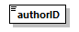
type | anre:Guid
properties
  content | simple
facets
  Kind | Value | Annotation
  length | 32
source | <xs:element name="authorID" type="anre:Guid" minOccurs="1" maxOccurs="1"/>

element Message/authorName
diagram | 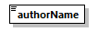
type | xs:string
properties
  content | simple
source | <xs:element name="authorName" type="xs:string" minOccurs="1" maxOccurs="1"/>

element Message/description
diagram | 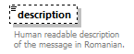
type | xs:string
properties
  minOcc | 0
  maxOcc | 1
  content | simple
annotation
  documentation
  Human readable description of the message in Romanian.
source | <xs:element name="description" type="xs:string" minOccurs="0" maxOccurs="1">  <xs:annotation>  <xs:documentation>Human readable description of the message in Romanian.</xs:documentation>  </xs:annotation>  </xs:element>

element Message/messageID
diagram | 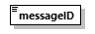
type | anre:Guid
properties
  content | simple
facets
  Kind | Value | Annotation
  length | 32
source | <xs:element name="messageID" type="anre:Guid" minOccurs="1" maxOccurs="1"/>

element Message/timestamp
diagram | 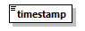
type | xs:dateTime
properties
  content | simple
source | <xs:element name="timestamp" type="xs:dateTime" minOccurs="1" maxOccurs="1"/>

complexType Operator
diagram | 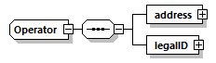
namespace | http://www.anre.ro/ANRESchema
used by
  elements | Operator Contract/operator PlaceCreatedByOperator/operator PlaceUpdatedByOperator/operator
source | <xs:complexType name="Operator">  <xs:sequence>  <xs:element name="address" type="anre:Address" minOccurs="1" maxOccurs="1"/>  <xs:element name="legalID" type="anre:LegalID" minOccurs="1" maxOccurs="1"/>  </xs:sequence>  </xs:complexType>

element Operator/address
diagram
type | anre:Address
properties
  content | complex
source | <xs:element name="address" type="anre:Address" minOccurs="1" maxOccurs="1"/>

element Operator/legalID
diagram
type | anre:LegalID
properties
  content | complex
attributes
  Name | Type | Use | Default | Fixed | Annotation
  number | xs:string | optional
  type | anre:LegalIDType | optional
source | <xs:element name="legalID" type="anre:LegalID" minOccurs="1" maxOccurs="1"/>

complexType Place
diagram | 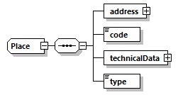
namespace | http://www.anre.ro/ANRESchema
used by
  elements | Place Contract/place PlaceCreatedByOperator/place PlaceUpdatedByOperator/place
source | <xs:complexType name="Place">  <xs:sequence>  <xs:element name="address" type="anre:Address" minOccurs="1" maxOccurs="1"/>  <xs:element name="code" type="xs:string" minOccurs="1" maxOccurs="1"/>  <xs:element name="technicalData" type="anre:TechnicalData" minOccurs="1" maxOccurs="1"/>  <xs:element name="type" type="anre:PlaceType" minOccurs="1" maxOccurs="1"/>  </xs:sequence>  </xs:complexType>

element Place/address
diagram
type | anre:Address
properties
  content | complex
source | <xs:element name="address" type="anre:Address" minOccurs="1" maxOccurs="1"/>

element Place/code
diagram | 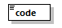
type | xs:string
properties
  content | simple
source | <xs:element name="code" type="xs:string" minOccurs="1" maxOccurs="1"/>

element Place/technicalData
diagram | 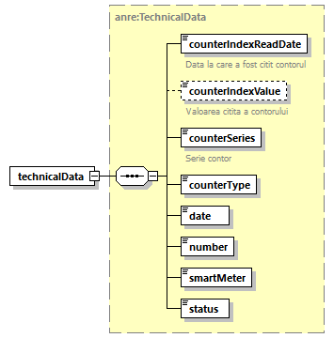
type | anre:TechnicalData
properties
  content | complex
source | <xs:element name="technicalData" type="anre:TechnicalData" minOccurs="1" maxOccurs="1"/>

element Place/type
diagram
type | anre:PlaceType
properties
  content | simple
facets
  Kind | Value | Annotation
  enumeration | CLC
  enumeration | POD
source | <xs:element name="type" type="anre:PlaceType" minOccurs="1" maxOccurs="1"/>

complexType PlaceCreatedByOperator
diagram | 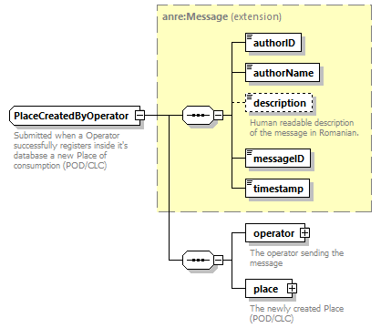
namespace | http://www.anre.ro/ANRESchema
type | extension of anre:Message
properties
  base | anre:Message
used by
  element | PlaceCreatedByOperator
annotation
  documentation
  Submitted when a Operator successfully registers inside it's database a new Place of consumption (POD/CLC)
source | <xs:complexType name="PlaceCreatedByOperator">  <xs:annotation>  <xs:documentation>Submitted when a Operator successfully registers inside it's database a new Place of consumption (POD/CLC)</xs:documentation>  </xs:annotation>  <xs:complexContent>  <xs:extension base="anre:Message">  <xs:sequence>  <xs:element name="operator" type="anre:Operator" minOccurs="1" maxOccurs="1">  <xs:annotation>  <xs:documentation>The operator sending the message</xs:documentation>  </xs:annotation>  </xs:element>  <xs:element name="place" type="anre:Place" minOccurs="1" maxOccurs="1">  <xs:annotation>  <xs:documentation>The newly created Place (POD/CLC)</xs:documentation>  </xs:annotation>  </xs:element>  </xs:sequence>  </xs:extension>  </xs:complexContent>  </xs:complexType>

element PlaceCreatedByOperator/operator
diagram | 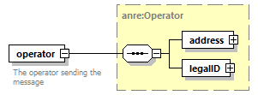
type | anre:Operator
properties
  content | complex
annotation
  documentation
  The operator sending the message
source | <xs:element name="operator" type="anre:Operator" minOccurs="1" maxOccurs="1">  <xs:annotation>  <xs:documentation>The operator sending the message</xs:documentation>  </xs:annotation>  </xs:element>

element PlaceCreatedByOperator/place
diagram | 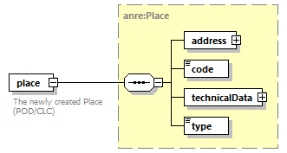
type | anre:Place
properties
  content | complex
annotation
  documentation
  The newly created Place (POD/CLC)
source | <xs:element name="place" type="anre:Place" minOccurs="1" maxOccurs="1">  <xs:annotation>  <xs:documentation>The newly created Place (POD/CLC)</xs:documentation>  </xs:annotation>  </xs:element>

complexType PlaceUpdatedByOperator
diagram | 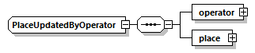
namespace | http://www.anre.ro/ANRESchema
used by
  element | PlaceUpdatedByOperator
source | <xs:complexType name="PlaceUpdatedByOperator">  <xs:sequence>  <xs:element name="operator" type="anre:Operator" minOccurs="1" maxOccurs="1"/>  <xs:element name="place" type="anre:Place" minOccurs="1" maxOccurs="1"/>  </xs:sequence>  </xs:complexType>

element PlaceUpdatedByOperator/operator
diagram | 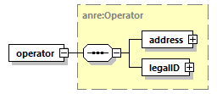
type | anre:Operator
properties
  content | complex
source | <xs:element name="operator" type="anre:Operator" minOccurs="1" maxOccurs="1"/>

element PlaceUpdatedByOperator/place
diagram
type | anre:Place
properties
  content | complex
source | <xs:element name="place" type="anre:Place" minOccurs="1" maxOccurs="1"/>

complexType Position
diagram | 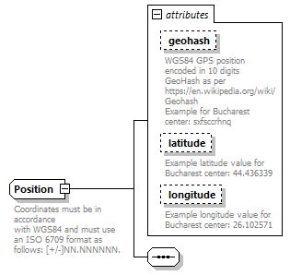
namespace | http://www.anre.ro/ANRESchema
used by
  elements | Position Address/position
attributes
  Name | Type | Use | Default | Fixed | Annotation
  geohash | xs:string | optional
    documentation
    WGS84 GPS position encoded in 10 digits GeoHash as per https://en.wikipedia.org/wiki/Geohash
    Example for Bucharest center: sxfsccrhnq
  latitude | xs:string | optional
    documentation
    Example latitude value for Bucharest center: 44.436339
  longitude | xs:string | optional
    documentation
    Example longitude value for Bucharest center: 26.102571
annotation
  documentation
  Coordinates must be in accordance
  with WGS84 and must use an ISO 6709 format as follows: [+/-]NN.NNNNNN.
source | <xs:complexType name="Position">  <xs:annotation>  <xs:documentation>Coordinates must be in accordance  with WGS84 and must use an ISO 6709 format as follows: [+/-]NN.NNNNNN.</xs:documentation>  </xs:annotation>  <xs:sequence/>  <xs:attribute name="geohash" type="xs:string" use="optional">  <xs:annotation>  <xs:documentation>WGS84 GPS position encoded in 10 digits GeoHash as per https://en.wikipedia.org/wiki/Geohash  Example for Bucharest center: sxfsccrhnq</xs:documentation>  </xs:annotation>  </xs:attribute>  <xs:attribute name="latitude" type="xs:string" use="optional">  <xs:annotation>  <xs:documentation>Example latitude value for Bucharest center: 44.436339</xs:documentation>  </xs:annotation>  </xs:attribute>  <xs:attribute name="longitude" type="xs:string" use="optional">  <xs:annotation>  <xs:documentation>Example longitude value for Bucharest center: 26.102571</xs:documentation>  </xs:annotation>  </xs:attribute>  </xs:complexType>

attribute Position/@geohash
type | xs:string
properties
  use | optional
annotation
  documentation
  WGS84 GPS position encoded in 10 digits GeoHash as per https://en.wikipedia.org/wiki/Geohash
  Example for Bucharest center: sxfsccrhnq
source | <xs:attribute name="geohash" type="xs:string" use="optional">  <xs:annotation>  <xs:documentation>WGS84 GPS position encoded in 10 digits GeoHash as per https://en.wikipedia.org/wiki/Geohash  Example for Bucharest center: sxfsccrhnq</xs:documentation>  </xs:annotation>  </xs:attribute>

attribute Position/@latitude
type | xs:string
properties
  use | optional
annotation
  documentation
  Example latitude value for Bucharest center: 44.436339
source | <xs:attribute name="latitude" type="xs:string" use="optional">  <xs:annotation>  <xs:documentation>Example latitude value for Bucharest center: 44.436339</xs:documentation>  </xs:annotation>  </xs:attribute>

attribute Position/@longitude
type | xs:string
properties
  use | optional
annotation
  documentation
  Example longitude value for Bucharest center: 26.102571
source | <xs:attribute name="longitude" type="xs:string" use="optional">  <xs:annotation>  <xs:documentation>Example longitude value for Bucharest center: 26.102571</xs:documentation>  </xs:annotation>  </xs:attribute>

complexType Supplier
diagram | 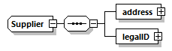
namespace | http://www.anre.ro/ANRESchema
used by
  elements | Supplier Contract/supplier
source | <xs:complexType name="Supplier">  <xs:sequence>  <xs:element name="address" type="anre:Address" minOccurs="1" maxOccurs="1"/>  <xs:element name="legalID" type="anre:LegalID" minOccurs="1" maxOccurs="1"/>  </xs:sequence>  </xs:complexType>

element Supplier/address
diagram
type | anre:Address
properties
  content | complex
source | <xs:element name="address" type="anre:Address" minOccurs="1" maxOccurs="1"/>

element Supplier/legalID
diagram
type | anre:LegalID
properties
  content | complex
attributes
  Name | Type | Use | Default | Fixed | Annotation
  number | xs:string | optional
  type | anre:LegalIDType | optional
source | <xs:element name="legalID" type="anre:LegalID" minOccurs="1" maxOccurs="1"/>

complexType TechnicalData
diagram | 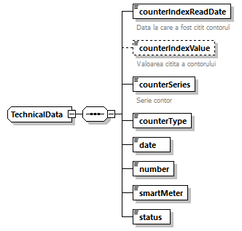
namespace | http://www.anre.ro/ANRESchema
used by
  elements | TechnicalData Place/technicalData
  complexTypes | TechnicalDataElectricity TechnicalDataGas
source | <xs:complexType name="TechnicalData">  <xs:sequence>  <xs:element name="counterIndexReadDate" type="xs:date" minOccurs="1" maxOccurs="1">  <xs:annotation>  <xs:documentation>Data la care a fost citit contorul</xs:documentation>  </xs:annotation>  </xs:element>  <xs:element name="counterIndexValue" type="xs:string" minOccurs="0" maxOccurs="1">  <xs:annotation>  <xs:documentation>Valoarea citita a contorului</xs:documentation>  </xs:annotation>  </xs:element>  <xs:element name="counterSeries" type="xs:string" minOccurs="1" maxOccurs="1">  <xs:annotation>  <xs:documentation>Serie contor</xs:documentation>  </xs:annotation>  </xs:element>  <xs:element name="counterType" type="anre:CounterType" minOccurs="1" maxOccurs="1"/>  <xs:element name="date" type="xs:date" minOccurs="1" maxOccurs="1"/>  <xs:element name="number" type="xs:string" minOccurs="1" maxOccurs="1"/>  <xs:element name="smartMeter" type="xs:boolean" minOccurs="1" maxOccurs="1"/>  <xs:element name="status" type="anre:TechnicalDataStatus" minOccurs="1" maxOccurs="1"/>  </xs:sequence>  </xs:complexType>

element TechnicalData/counterIndexReadDate
diagram | 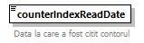
type | xs:date
properties
  content | simple
annotation
  documentation
  Data la care a fost citit contorul
source | <xs:element name="counterIndexReadDate" type="xs:date" minOccurs="1" maxOccurs="1">  <xs:annotation>  <xs:documentation>Data la care a fost citit contorul</xs:documentation>  </xs:annotation>  </xs:element>

element TechnicalData/counterIndexValue
diagram | 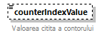
type | xs:string
properties
  minOcc | 0
  maxOcc | 1
  content | simple
annotation
  documentation
  Valoarea citita a contorului
source | <xs:element name="counterIndexValue" type="xs:string" minOccurs="0" maxOccurs="1">  <xs:annotation>  <xs:documentation>Valoarea citita a contorului</xs:documentation>  </xs:annotation>  </xs:element>

element TechnicalData/counterSeries
diagram | 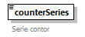
type | xs:string
properties
  content | simple
annotation
  documentation
  Serie contor
source | <xs:element name="counterSeries" type="xs:string" minOccurs="1" maxOccurs="1">  <xs:annotation>  <xs:documentation>Serie contor</xs:documentation>  </xs:annotation>  </xs:element>

element TechnicalData/counterType
diagram | 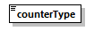
type | anre:CounterType
properties
  content | simple
facets
  Kind | Value | Annotation
  enumeration | ACTIVE
  enumeration | GAS
  enumeration | REACTIVE
source | <xs:element name="counterType" type="anre:CounterType" minOccurs="1" maxOccurs="1"/>

element TechnicalData/date
diagram
type | xs:date
properties
  content | simple
source | <xs:element name="date" type="xs:date" minOccurs="1" maxOccurs="1"/>

element TechnicalData/number
diagram
type | xs:string
properties
  content | simple
source | <xs:element name="number" type="xs:string" minOccurs="1" maxOccurs="1"/>

element TechnicalData/smartMeter
diagram | 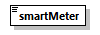
type | xs:boolean
properties
  content | simple
source | <xs:element name="smartMeter" type="xs:boolean" minOccurs="1" maxOccurs="1"/>

element TechnicalData/status
diagram | 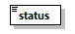
type | anre:TechnicalDataStatus
properties
  content | simple
facets
  Kind | Value | Annotation
  enumeration | CONECTAT
  enumeration | DECONECTAT
source | <xs:element name="status" type="anre:TechnicalDataStatus" minOccurs="1" maxOccurs="1"/>

complexType TechnicalDataElectricity
diagram | 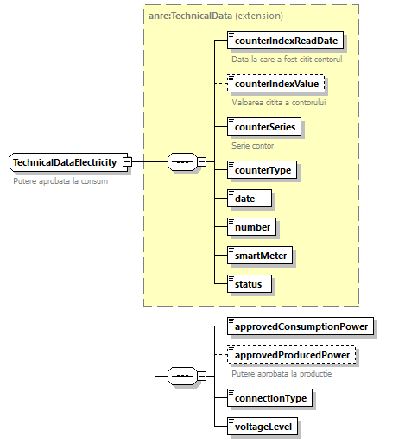
namespace | http://www.anre.ro/ANRESchema
type | extension of anre:TechnicalData
properties
  base | anre:TechnicalData
used by
  element | TechnicalDataElectricity
annotation
  documentation
  Putere aprobata la consum
source | <xs:complexType name="TechnicalDataElectricity">  <xs:annotation>  <xs:documentation>Putere aprobata la consum</xs:documentation>  </xs:annotation>  <xs:complexContent>  <xs:extension base="anre:TechnicalData">  <xs:sequence>  <xs:element name="approvedConsumptionPower" type="xs:double" minOccurs="1" maxOccurs="1"/>  <xs:element name="approvedProducedPower" type="xs:double" minOccurs="0" maxOccurs="1">  <xs:annotation>  <xs:documentation>Putere aprobata la productie</xs:documentation>  </xs:annotation>  </xs:element>  <xs:element name="connectionType" type="anre:ConnectionType" minOccurs="1" maxOccurs="1"/>  <xs:element name="voltageLevel" type="xs:double" minOccurs="1" maxOccurs="1"/>  </xs:sequence>  </xs:extension>  </xs:complexContent>  </xs:complexType>

element TechnicalDataElectricity/approvedConsumptionPower
diagram | 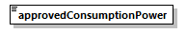
type | xs:double
properties
  content | simple
source | <xs:element name="approvedConsumptionPower" type="xs:double" minOccurs="1" maxOccurs="1"/>

element TechnicalDataElectricity/approvedProducedPower
diagram | 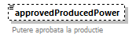
type | xs:double
properties
  minOcc | 0
  maxOcc | 1
  content | simple
annotation
  documentation
  Putere aprobata la productie
source | <xs:element name="approvedProducedPower" type="xs:double" minOccurs="0" maxOccurs="1">  <xs:annotation>  <xs:documentation>Putere aprobata la productie</xs:documentation>  </xs:annotation>  </xs:element>

element TechnicalDataElectricity/connectionType
diagram | 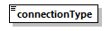
type | anre:ConnectionType
properties
  content | simple
facets
  Kind | Value | Annotation
  enumeration | MONOFAZAT
  enumeration | TRIFAZAT
source | <xs:element name="connectionType" type="anre:ConnectionType" minOccurs="1" maxOccurs="1"/>

element TechnicalDataElectricity/voltageLevel
diagram | 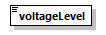
type | xs:double
properties
  content | simple
source | <xs:element name="voltageLevel" type="xs:double" minOccurs="1" maxOccurs="1"/>

complexType TechnicalDataGas
diagram | 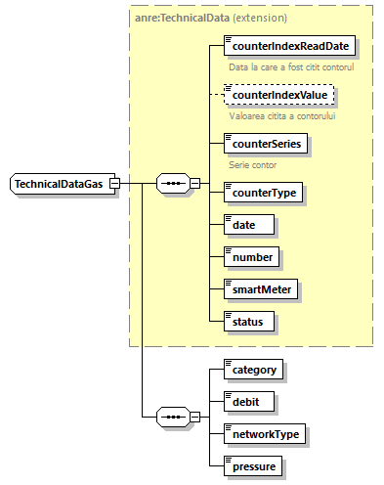
namespace | http://www.anre.ro/ANRESchema
type | extension of anre:TechnicalData
properties
  base | anre:TechnicalData
used by
  element | TechnicalDataGas
source | <xs:complexType name="TechnicalDataGas">  <xs:complexContent>  <xs:extension base="anre:TechnicalData">  <xs:sequence>  <xs:element name="category" type="anre:ConsumptionCategory" minOccurs="1" maxOccurs="1"/>  <xs:element name="debit" type="xs:double" minOccurs="1" maxOccurs="1"/>  <xs:element name="networkType" type="anre:NetworkType" minOccurs="1" maxOccurs="1"/>  <xs:element name="pressure" type="xs:double" minOccurs="1" maxOccurs="1"/>  </xs:sequence>  </xs:extension>  </xs:complexContent>  </xs:complexType>

element TechnicalDataGas/category
diagram | 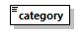
type | anre:ConsumptionCategory
properties
  content | simple
facets
  Kind | Value | Annotation
  enumeration | C1
  enumeration | C2
  enumeration | C3
source | <xs:element name="category" type="anre:ConsumptionCategory" minOccurs="1" maxOccurs="1"/>

element TechnicalDataGas/debit
diagram | 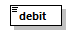
type | xs:double
properties
  content | simple
source | <xs:element name="debit" type="xs:double" minOccurs="1" maxOccurs="1"/>

element TechnicalDataGas/networkType
diagram | 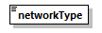
type | anre:NetworkType
properties
  content | simple
facets
  Kind | Value | Annotation
  enumeration | CA
  enumeration | D
  enumeration | T
source | <xs:element name="networkType" type="anre:NetworkType" minOccurs="1" maxOccurs="1"/>

element TechnicalDataGas/pressure
diagram | 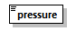
type | xs:double
properties
  content | simple
source | <xs:element name="pressure" type="xs:double" minOccurs="1" maxOccurs="1"/>

simpleType ConnectionType
namespace | http://www.anre.ro/ANRESchema
type | restriction of xs:string
properties
  base | xs:string
used by
  element | TechnicalDataElectricity/connectionType
facets
  Kind | Value | Annotation
  enumeration | MONOFAZAT
  enumeration | TRIFAZAT
source | <xs:simpleType name="ConnectionType">  <xs:restriction base="xs:string">  <xs:enumeration value="MONOFAZAT"/>  <xs:enumeration value="TRIFAZAT"/>  </xs:restriction>  </xs:simpleType>

simpleType ConsumptionCategory
namespace | http://www.anre.ro/ANRESchema
type | restriction of xs:string
properties
  base | xs:string
used by
  element | TechnicalDataGas/category
facets
  Kind | Value | Annotation
  enumeration | C1
  enumeration | C2
  enumeration | C3
source | <xs:simpleType name="ConsumptionCategory">  <xs:restriction base="xs:string">  <xs:enumeration value="C1"/>  <xs:enumeration value="C2"/>  <xs:enumeration value="C3"/>  </xs:restriction>  </xs:simpleType>

simpleType ContractType
namespace | http://www.anre.ro/ANRESchema
type | restriction of xs:string
properties
  base | xs:string
used by
  element | Contract/type
facets
  Kind | Value | Annotation
  enumeration | FURNIZARE
  enumeration | RETEA
  enumeration | TRANSPORT
source | <xs:simpleType name="ContractType">  <xs:restriction base="xs:string">  <xs:enumeration value="FURNIZARE"/>  <xs:enumeration value="RETEA"/>  <xs:enumeration value="TRANSPORT"/>  </xs:restriction>  </xs:simpleType>

simpleType CounterType
namespace | http://www.anre.ro/ANRESchema
type | restriction of xs:string
properties
  base | xs:string
used by
  element | TechnicalData/counterType
facets
  Kind | Value | Annotation
  enumeration | ACTIVE
  enumeration | GAS
  enumeration | REACTIVE
source | <xs:simpleType name="CounterType">  <xs:restriction base="xs:string">  <xs:enumeration value="ACTIVE"/>  <xs:enumeration value="GAS"/>  <xs:enumeration value="REACTIVE"/>  </xs:restriction>  </xs:simpleType>

simpleType County
namespace | http://www.anre.ro/ANRESchema
type | restriction of xs:string
properties
  base | xs:string
used by
  element | Address/county
facets
  Kind | Value | Annotation
  enumeration | AB
  enumeration | AG
  enumeration | AR
  enumeration | B
  enumeration | BC
  enumeration | BH
  enumeration | BN
  enumeration | BR
  enumeration | BT
  enumeration | BV
  enumeration | BZ
  enumeration | CJ
  enumeration | CL
  enumeration | CS
  enumeration | CT
  enumeration | CV
  enumeration | DB
  enumeration | DJ
  enumeration | GJ
  enumeration | GL
  enumeration | GR
  enumeration | HD
  enumeration | HR
  enumeration | IF
  enumeration | IL
  enumeration | IS
  enumeration | MH
  enumeration | MM
  enumeration | MS
  enumeration | NT
  enumeration | OT
  enumeration | PH
  enumeration | SB
  enumeration | SJ
  enumeration | SM
  enumeration | SV
  enumeration | TL
  enumeration | TM
  enumeration | TR
  enumeration | VL
  enumeration | VN
  enumeration | VS
source | <xs:simpleType name="County">  <xs:restriction base="xs:string">  <xs:enumeration value="AB"/>  <xs:enumeration value="AG"/>  <xs:enumeration value="AR"/>  <xs:enumeration value="B"/>  <xs:enumeration value="BC"/>  <xs:enumeration value="BH"/>  <xs:enumeration value="BN"/>  <xs:enumeration value="BR"/>  <xs:enumeration value="BT"/>  <xs:enumeration value="BV"/>  <xs:enumeration value="BZ"/>  <xs:enumeration value="CJ"/>  <xs:enumeration value="CL"/>  <xs:enumeration value="CS"/>  <xs:enumeration value="CT"/>  <xs:enumeration value="CV"/>  <xs:enumeration value="DB"/>  <xs:enumeration value="DJ"/>  <xs:enumeration value="GJ"/>  <xs:enumeration value="GL"/>  <xs:enumeration value="GR"/>  <xs:enumeration value="HD"/>  <xs:enumeration value="HR"/>  <xs:enumeration value="IF"/>  <xs:enumeration value="IL"/>  <xs:enumeration value="IS"/>  <xs:enumeration value="MH"/>  <xs:enumeration value="MM"/>  <xs:enumeration value="MS"/>  <xs:enumeration value="NT"/>  <xs:enumeration value="OT"/>  <xs:enumeration value="PH"/>  <xs:enumeration value="SB"/>  <xs:enumeration value="SJ"/>  <xs:enumeration value="SM"/>  <xs:enumeration value="SV"/>  <xs:enumeration value="TL"/>  <xs:enumeration value="TM"/>  <xs:enumeration value="TR"/>  <xs:enumeration value="VL"/>  <xs:enumeration value="VN"/>  <xs:enumeration value="VS"/>  </xs:restriction>  </xs:simpleType>

simpleType Email
namespace | http://www.anre.ro/ANRESchema
type | xs:string
properties
  base | xs:string
source | <xs:simpleType name="Email">  <xs:restriction base="xs:string"/>  </xs:simpleType>

simpleType Guid
namespace | http://www.anre.ro/ANRESchema
type | restriction of xs:string
properties
  base | xs:string
used by
  elements | Message/authorID Message/messageID
facets
  Kind | Value | Annotation
  length | 32
source | <xs:simpleType name="Guid">  <xs:restriction base="xs:string">  <xs:length value="32"/>  </xs:restriction>  </xs:simpleType>

simpleType Incorporation
namespace | http://www.anre.ro/ANRESchema
type | restriction of xs:string
properties
  base | xs:string
facets
  Kind | Value | Annotation
  enumeration | AltePersoaneJuridice
  enumeration | AutoritateInstitutiePublica
  enumeration | CompanieNationala
  enumeration | Fundatie
  enumeration | InstitutCulturalAlUnuiStat
  enumeration | InstitutieDeCredit
  enumeration | MisiuneDiplomatica
  enumeration | OficiuConsular
  enumeration | OrganizatieAsociatieCuPersonalitateJuridica
  enumeration | OrganizatiePatronala
  enumeration | OrganizatieSindicala
  enumeration | RegieAutonoma
  enumeration | ReprezentantaComercialaSiEconomicaAleAltuiStat
  enumeration | ReprezentantaDinRomaniaPentruPJStraina
  enumeration | SocietateComerciala
  enumeration | SocietateCooperativa
  enumeration | SocietateNationala
source | <xs:simpleType name="Incorporation">  <xs:restriction base="xs:string">  <xs:enumeration value="AltePersoaneJuridice"/>  <xs:enumeration value="AutoritateInstitutiePublica"/>  <xs:enumeration value="CompanieNationala"/>  <xs:enumeration value="Fundatie"/>  <xs:enumeration value="InstitutCulturalAlUnuiStat"/>  <xs:enumeration value="InstitutieDeCredit"/>  <xs:enumeration value="MisiuneDiplomatica"/>  <xs:enumeration value="OficiuConsular"/>  <xs:enumeration value="OrganizatieAsociatieCuPersonalitateJuridica"/>  <xs:enumeration value="OrganizatiePatronala"/>  <xs:enumeration value="OrganizatieSindicala"/>  <xs:enumeration value="RegieAutonoma"/>  <xs:enumeration value="ReprezentantaComercialaSiEconomicaAleAltuiStat"/>  <xs:enumeration value="ReprezentantaDinRomaniaPentruPJStraina"/>  <xs:enumeration value="SocietateComerciala"/>  <xs:enumeration value="SocietateCooperativa"/>  <xs:enumeration value="SocietateNationala"/>  </xs:restriction>  </xs:simpleType>

simpleType LegalIDType
namespace | http://www.anre.ro/ANRESchema
type | restriction of xs:string
properties
  base | xs:string
used by
  attribute | LegalID/@type
facets
  Kind | Value | Annotation
  enumeration | CNP
  enumeration | CUI
  enumeration | OTHER
  enumeration | PASSPORT
source | <xs:simpleType name="LegalIDType">  <xs:restriction base="xs:string">  <xs:enumeration value="CNP"/>  <xs:enumeration value="CUI"/>  <xs:enumeration value="OTHER"/>  <xs:enumeration value="PASSPORT"/>  </xs:restriction>  </xs:simpleType>

simpleType NetworkType
namespace | http://www.anre.ro/ANRESchema
type | restriction of xs:string
properties
  base | xs:string
used by
  element | TechnicalDataGas/networkType
facets
  Kind | Value | Annotation
  enumeration | CA
  enumeration | D
  enumeration | T
source | <xs:simpleType name="NetworkType">  <xs:restriction base="xs:string">  <xs:enumeration value="CA"/>  <xs:enumeration value="D"/>  <xs:enumeration value="T"/>  </xs:restriction>  </xs:simpleType>

simpleType Phone
namespace | http://www.anre.ro/ANRESchema
type | xs:string
properties
  base | xs:string
source | <xs:simpleType name="Phone">  <xs:restriction base="xs:string"/>  </xs:simpleType>

simpleType PlaceType
namespace | http://www.anre.ro/ANRESchema
type | restriction of xs:string
properties
  base | xs:string
used by
  element | Place/type
facets
  Kind | Value | Annotation
  enumeration | CLC
  enumeration | POD
source | <xs:simpleType name="PlaceType">  <xs:restriction base="xs:string">  <xs:enumeration value="CLC"/>  <xs:enumeration value="POD"/>  </xs:restriction>  </xs:simpleType>

simpleType TechnicalDataStatus
namespace | http://www.anre.ro/ANRESchema
type | restriction of xs:string
properties
  base | xs:string
used by
  element | TechnicalData/status
facets
  Kind | Value | Annotation
  enumeration | CONECTAT
  enumeration | DECONECTAT
source | <xs:simpleType name="TechnicalDataStatus">  <xs:restriction base="xs:string">  <xs:enumeration value="CONECTAT"/>  <xs:enumeration value="DECONECTAT"/>  </xs:restriction>  </xs:simpleType>

XML Schema documentation generated by XMLSpy Schema Editor http://www.altova.com/xmlspy

